USER MANUAL

**Table of Contents**

Minimum System Requirement………………………………………………………….3

Getting Started…………………………………………………………………………….4

1. Maintain Unit of Measure (UOM)……………………………………….………5
2. Maintain Services………………………………………………………………….6
3. Maintain Stock……………………………………………………………………..8
4. Process Sales Transaction……………………………………………………….10

4.1 Process Sales Transaction……………………………………………………..11

1. Process Sales Line Details……………………………………………………….12

Retrieving Reports…………………………………………………………….…………14

1. Monthly Sales Report……………………………………….…………………..14
2. Stock Markup% Raking Report………………………………………….…….15

Exception Handling…………………………………………………………………..….16

1. Maintain Unit of Measure (UOM)……………………………………….………5
2. Maintain Services………………………………………………………………….6
3. Maintain Stock……………………………………………………………………..8
4. Process Sales Line Details……………………………………………………….12

**Minimum System Requirement**

1. **Software Requirement**

* Windows 8

.NET Framework 4.5 and its point releases

.NET Framework 4.5.1 (installable separately)

* Windows 10

Version 1507

.NET Framework 4.6

.NET Framework 4.6.1 (installable separately)

* Supports Windows Server 2008 SP2 and upwards

1. **Hardware Requirement**

* 1GHz Processor
* 512MB RAM
* Minimum of 4.5 GB on 32 and 64-bit
* DirectX9 capable graphics adapter is recommended

**Getting Started**

Open the application to display the menu window.

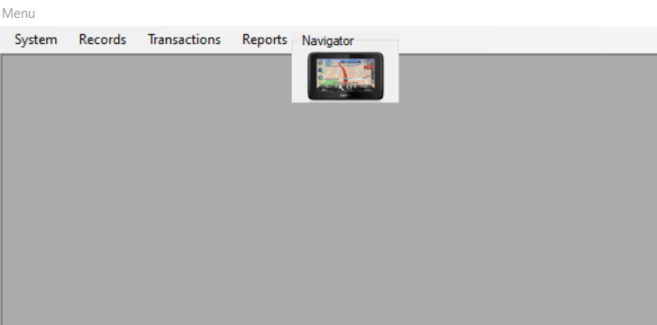

Navigator

Sales

Sales Report

Stock Report

Unit of Measure

Services

Stock

Exit

The forms in the application can be accessed via the Menu Strip or

For quick navigation use the Navigator button.

Navigator

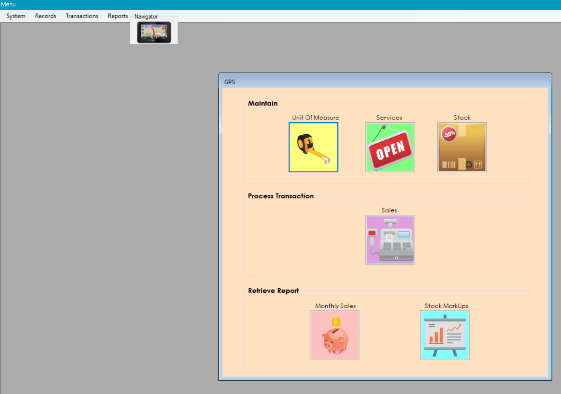

Sales Report

Stock Report

Sales

Unit of Measure

Services

Stock

1. **Maintain Unit of Measure (UOM)**

1.1

1.3

1.2

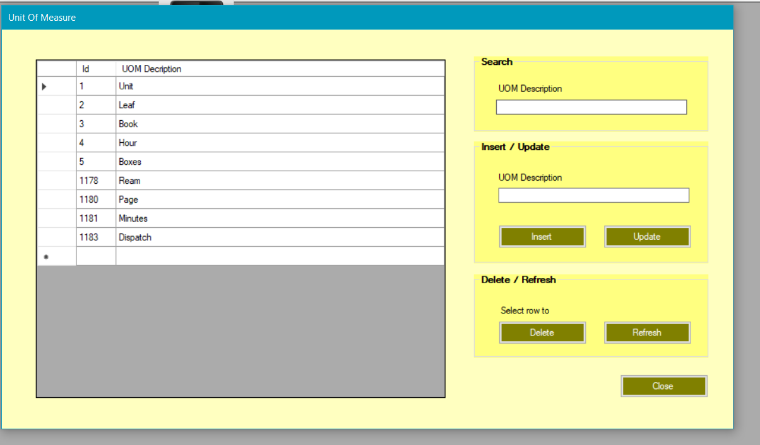

1.8.1

1.8.2

1.7

1.5

1.4441

1.6

* Enter UOM description in the search box (1.1) to automatically search DataGridView (1.8) for a match.
* Enter a new description in textbox (1.2) and press insert button (1.3) to insert new UOM into database.
* Select an entry on DataGridView by clicking along the row in the first column see (1.8.1). The entry should populate textbox (1.2). Update the description in textbox (1.2) and press update button (1.4) to insert update into the database on the UOM selected.
* To delete an entry, select desired row in the first column see (1.8.1) and press delete button (1.7). The system will confirm if you are certain to delete the entry and, on the confirmation, the selected entry is deleted from the UOM table in the database.
* Press refresh button (1.5) to clear textboxes and DataGridView selection and to reload the DataGridView with updated records.
* Close the form by either clicking the close button (1.6) or by double-clicking inside the DataGridView see (1.8.2)

1. **Maintain Services**

2.3.1

2.2

2.1

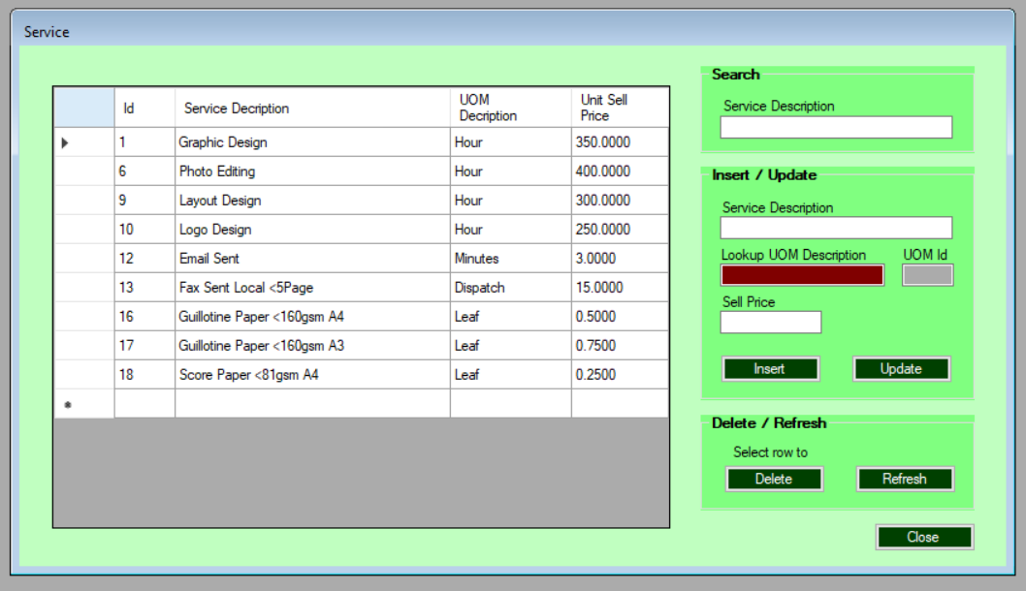

2.10.2

2.10.1

2.6

2.8

2.9

2.7

2.5

2.4

2.3.241

* Enter service description in the search box (2.1) to automatically search DataGridView (2.10) for a match.
* Enter a new description in textbox (2.2), double-click (2.3.1) to open the UOM form above. Double click an entry on the UOM form to select the entry and close the UOM form. The UOM description in (2.3.1) and the UOM id in (2.3.2) should automatically populate. Enter a sell price in (2.4) and press insert button (2.5) to insert new Service record into the database.
* Select an entry on DataGridView by clicking along the row in the first column see (2.10.1). The entry should populate textboxes (2.2), (2.3.1), 2.3.2) and (2.4). Update the description in textbox (2.2) or attach other UOM from double-clicking (2.3.1) and obtaining new UOM and/or enter new sell price in (2.4). Press update button (2.6) to insert updates into the database on Service selected.
* To delete an entry, select desired row in the first column see (2.10.1) and press delete button (2.7). The system will confirm if you are certain to delete the entry and, on the confirmation, the selected entry is deleted from the Services table in the database.
* Press refresh button (2.8) to clear textboxes and DataGridView selection and to reload the DataGridView with updated records.
* Close the form by either clicking the close button (2.9) or by double-clicking inside the DataGridView see (2.10.2)

1. **Maintain Stock**

3.1

3.2

3.3.1

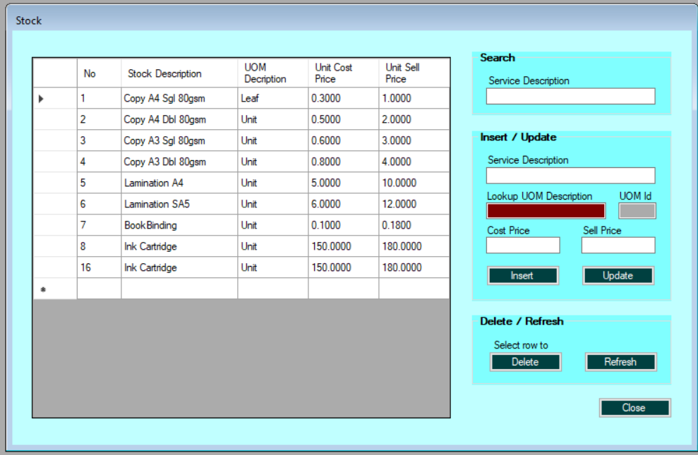

3.4

3.100

3.5

3.7

3.8

3.9

3.6

3.3.241

3.11.2

3.11.1

* Enter stock description in the search box (3.1) to automatically search DataGridView (3.11) for a match.
* Enter a new description in textbox (3.2), double-click (3.3.1) to open the UOM form above. Double click an entry on the UOM form to select the entry and close the UOM form. The UOM description in (3.3.1) and the UOM id in (3.3.2) should automatically populate. Enter a cost price in (3.4) and a sell price in (3.5) and press insert button (3.6) to insert new Stock record into database.
* Select an entry on DataGridView by clicking along the row in the first column see (3.11.1). The entry should populate textboxes (3.2), (3.3.1), 3.3.2), (3.4) and (3.5). Update the description in textbox (3.2) or attach other UOM from double-clicking (3.3.1) and obtaining new UOM and/or enter new cost price in (3.4) and/or new sell price in (3.4). Press update button (3.6) to insert updates on Stock selected, into database.
* To delete an entry, select desired row in the first column see (3.11.1) and press delete button (3.7). The system will confirm if you are certain to delete the entry and, on the confirmation, the selected entry is deleted from the Stock table in the database.
* Press refresh button (3.8) to clear textboxes and DataGridView selection and to reload the DataGridView with updated records.
* Close the form by either clicking the close button (3.10) or by double-clicking inside the DataGridView see (3.11.2)

1. **Process Sales Transaction**

4.1

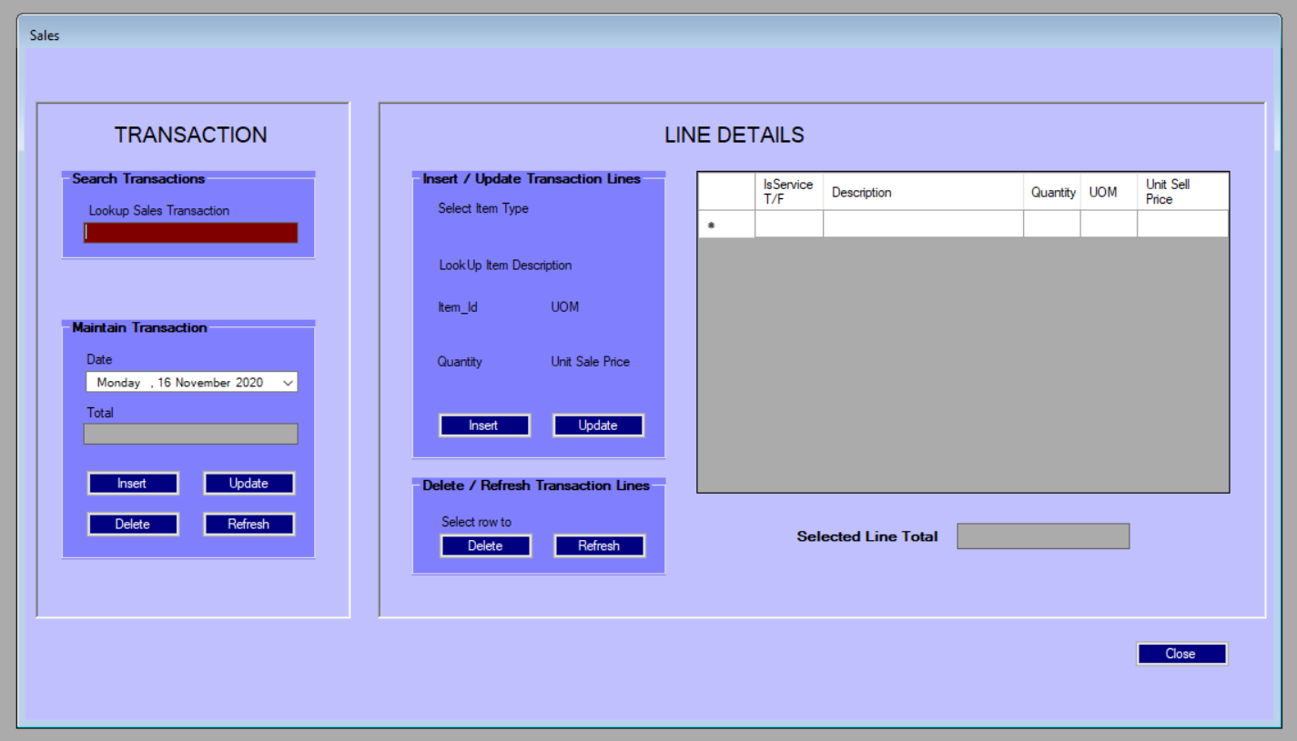

4.7

4.5

4.6

4.4

4.3

4.2

4.7

* To insert a new sale transaction, select a date from the date picker in 4.2. and press the insert button at (4.4). The new transaction number will automatically populate in (4.1).
* To update an existing sale transaction, double-click 4.1 to open the sale transaction lookup window. Select a date from the date-picker (4.1.1) to search the existing transaction list in the DataGridView for a given transaction. Once a selection is made by clicking on the first column in the DataGridView (4.1.2), the label for the selected No (4.1.3) populates automatically.
* Press refresh button (4.1.4) to clear DataGridView selection and to reload the DataGridView.
* Close the form by either clicking the close button (4.1.5) or by double-clicking inside the DataGridView to select that record see (4.1.6).

**4.1 Process Sales Transaction**

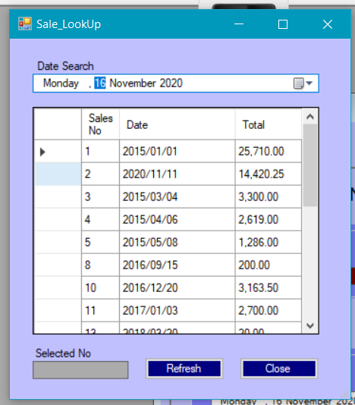

4.1.6

4.1.3

4.1.1

4.1.2

4.1.4

4.1.5

* The sale transaction number (4.1) and date in (4.2) and the total in (4.3) should automatically populate. Select another date in (4.2) and press button update at (4.5) to update the sale transaction’s date.
* To delete a sale transaction, select desired transaction from the Sale Lookup form (4.1) – double click on the entry to select it and close the lookup form. Press delete button (4.6). The system will confirm if you are certain to delete the entry and, on the confirmation, the selected entry is deleted from the Stock table in the database.
* Press refresh button (4.7) to clear controls and DataGridView selections on both header and line details sections.
* Close the form by either clicking the close button (4.7).

1. **Process Sales Line Details**

5.1

5.2.1

5.2.2

5.3

5.5

5.4

5.7

5.6

5.8

5.9

5.10.1

5.10.2

5.11

5.13

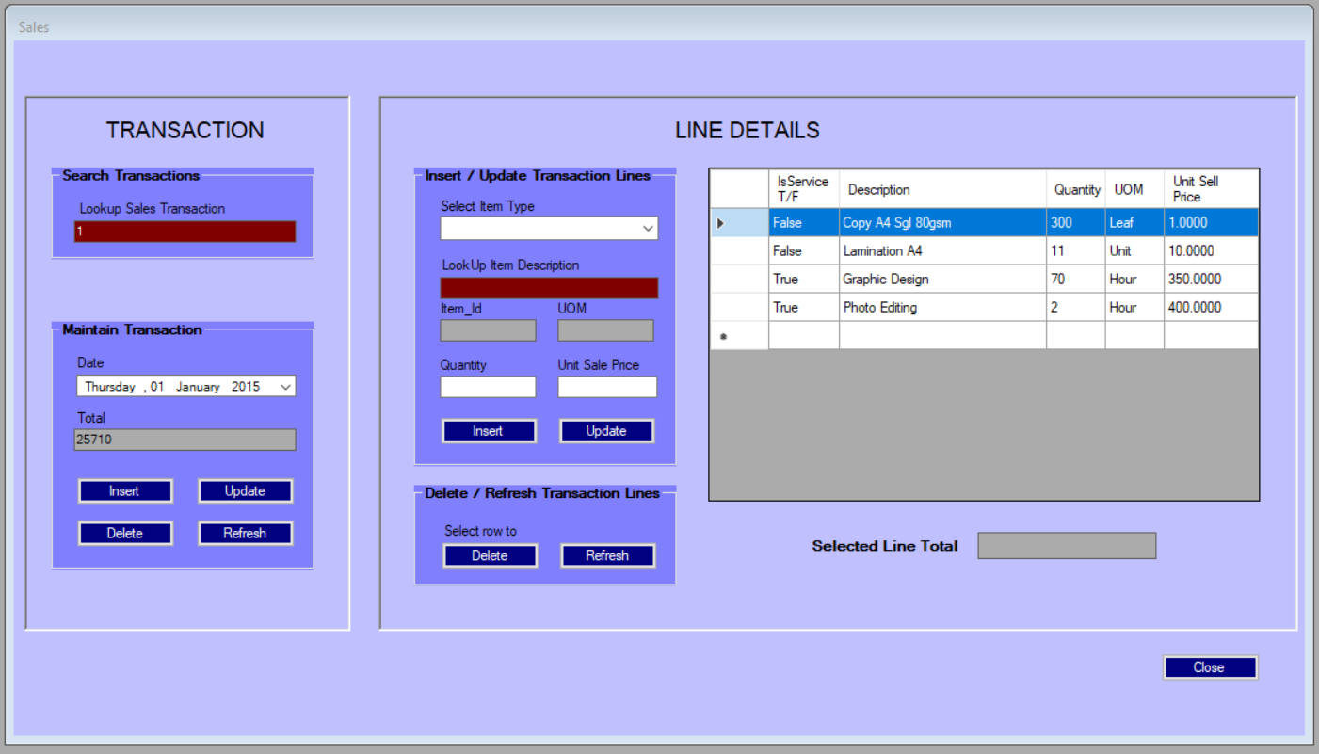

5.12

* First select or create a sale transaction before attempting to add line detail. The line detail controls will be blanked out if a sale transaction (header) is not selected, for the detail lines to be attached to.
* To insert a new sale line detail, select either stock or service from the dropdown menu (5.1). Double-click the textbox at (5.2.1) to open either the stock or service maintenance forms - depending on the selection made in (5.1) - to choose the desired service or stock item and close the maintenance form. The item description in (5.2.1) and the item id in (5.2.2) and the UOM description in (5.3) and the standard unit sale price in (5.4) should automatically populate. Either change or leave the sell price in (5.4) and enter a quantity in (5.5). Press insert button (5.6) to insert new sale line detail record into database.
* Select an entry on DataGridView by clicking along the row in the first column see (5.10.1). The entry should populate textboxes (5.1), (5.2.1), (5.2.2), (5.3), (5.4), (5.5) and (5.11). Only the quantity in textbox (5.5) and the Unit Sale Price in (5.4) can be updated. Press update button (5.7) to insert updates into database, on sale line detail selected.
* To delete an entry, select desired row in the first column see (5.10.1) and press delete button (5.12). The system will confirm if you are certain to delete the entry and, on the confirmation, the selected entry is deleted from the Stock table in the database.
* Press refresh button (5.9) to clear textboxes and DataGridView selection and to reload the DataGridView with updated records.
* Close the form by clicking the close button (5.13).

**Retrieving Reports**

1.3

1.2

1.1

1. **Monthly Sales Report**

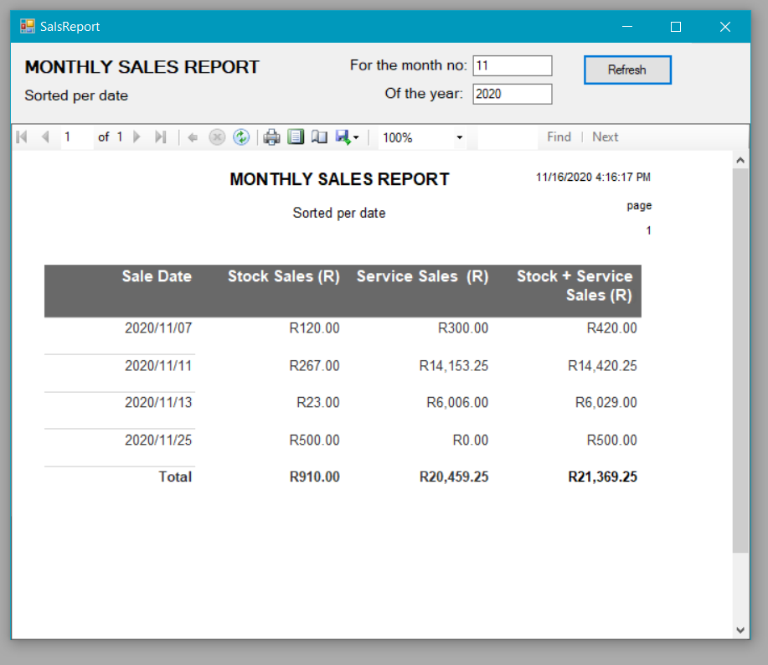

1.4

1.5

* Enter the number of the month for which the report is required at (1.1), the year into (1.2) and press the refresh button (1.3).
* The report extracts all the sales for a given month in a given year. It sorts and groups the transactions per day. Shows the sales per stock items, service items and the sum of the two. The report also shows totals for the month in the last row.
* The date and time when the report was extracted as well as the page number appears in the header to the right (1.4).
* Controls (1.5) can be used to print-preview, adjust printing settings and print, as well as export the report to excel, pdf, etc.

1. **Stock Markup% Raking Report**

1.1

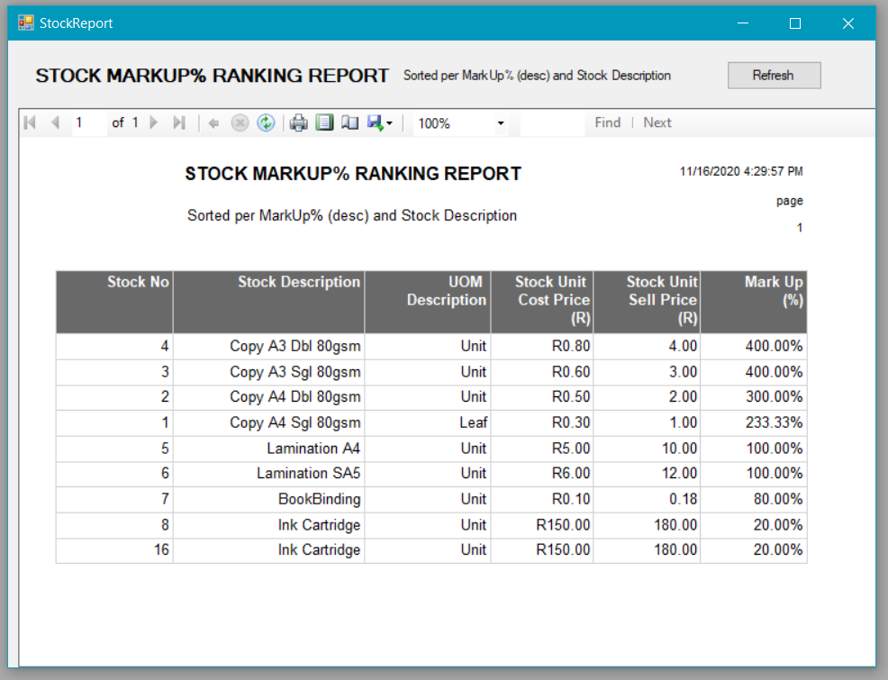

1.2

* The report calculated the mark-up percentage on the cost price on the last column and is sorted per the mark-up column, (then per description), to provide a ranking from high to low. This is to indicate to the user which stock items are most profitable to sell. This report can also be used when consideration is required for discount requests.
* The date and time when the report was extracted as well as the page number appears in the header to the right (1.4).
* Controls (1.5) can be used to print-preview, adjust printing settings and print, as well as export the report to excel, pdf, etc.

**Exception Handling**

1. **Maintain Unit of Measure**

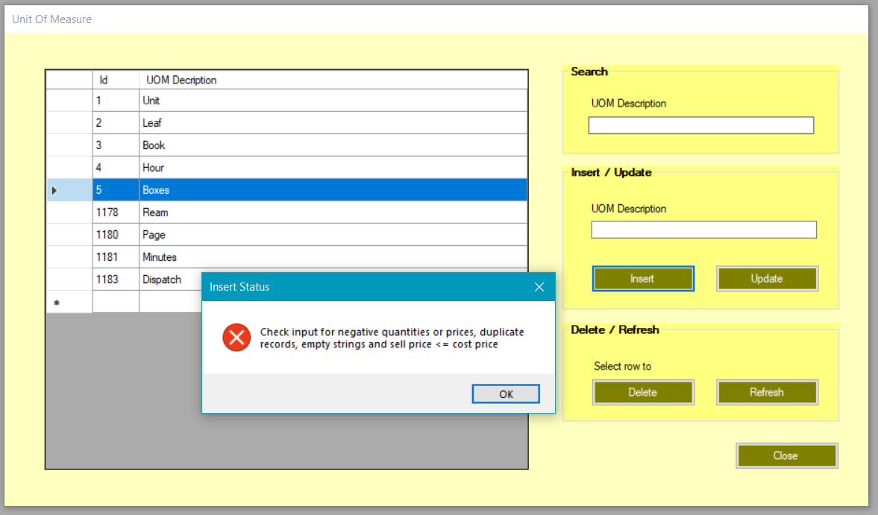

An error message will appear if the user attempt to insert/update the following:

* an empty string for the UOM Description field
* a duplicate record for the UOM Description field

1. **Maintain Services**

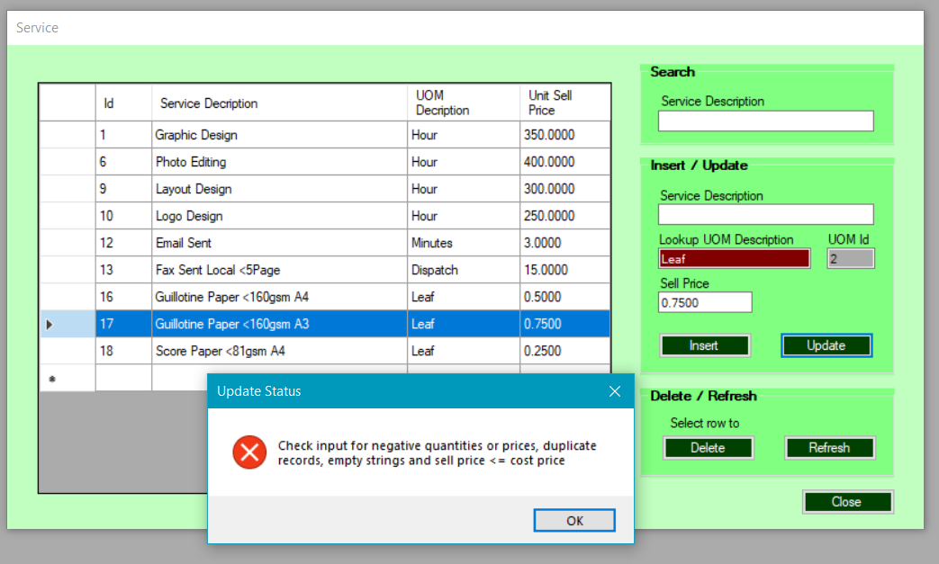

An error message will appear if the user attempt to insert/update the following:

* empty string for the Service Description field or Sell Price or UOM
* negative Sell Price
* a duplicate record on Service Description field and UOM Id

1. **Maintain Stock**

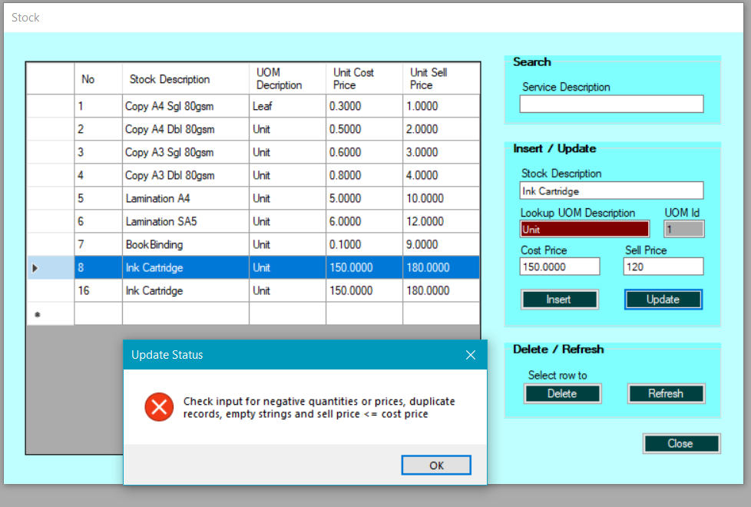

An error message will appear if the user attempt to insert/update the following:

* empty string for the Service Description field, Cost Price or Sell Price
* negative Sell Price / Cost Price
* cost Price less than Sell Price
* a duplicate record on Stock Description field and UOM Id

1. **Process Sales Line Details**

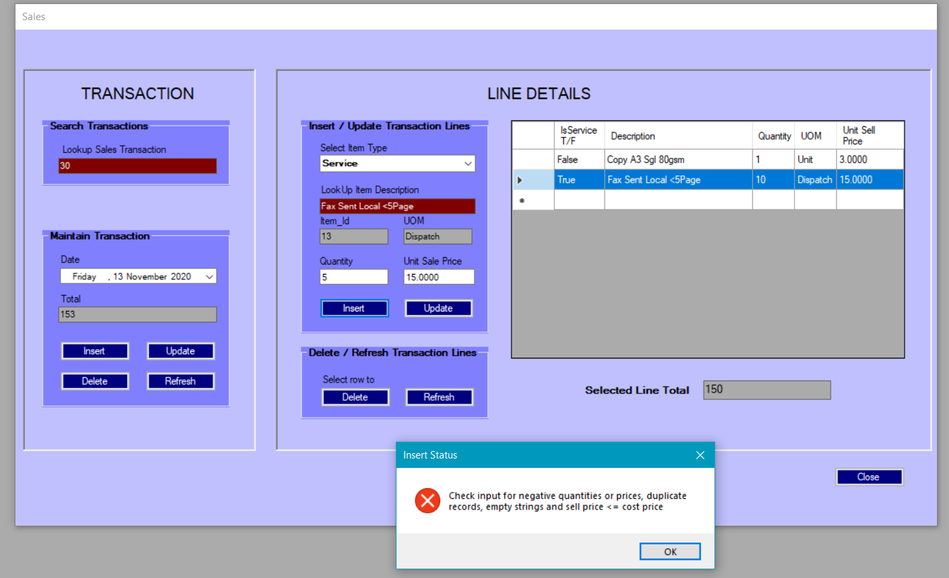

An error message will appear if the user attempt to insert/update the following:

* empty record for any field in “Insert/Update Transaction Line” section
* negative Quantity or Sell Price
* a duplicate entry on Service or Stock item already added to the Line Details

NB: Update only changes Quantity or Unit Sale Price, for any other changes required to the Service or Stock Item Description or Unit of Measure:

* delete the unwanted item
* double-click the Lookup Item Description, make the required insert or update and then select the required item from either the Stock or the Services form